Software Requirements Specification
for
Vacation 4U
Version 1.0 approved
Prepared by
Elie Bracha
Idan Fadlon
Lihi Sabag
Sergey Pechyoni
Avital Mahgaerefte
Neriya Zudi

<organization> <date created>
Table of Contents
Table of Contents ii
Revision History ii
1. Introduction 1
1.1 Purpose 1
1.2 Document Conventions 1
1.3 Intended Audience and Reading Suggestions 1
1.4 Product Scope 1
1.5 References 1
2. Overall Description 2
2.1 Product Perspective 2
2.2 Product Functions 2
2.2.1 Travel agent menu ……………………………………………………………………………….2
2.2.1 Costumer menu …………………………………………………………………………………..3
2.3 User Classes and Characteristics 4
2.4 Operating Environment 4
2.5 Design and Implementation Constraints 4
2.6 User Documentation 4
2.7 Assumptions and Dependencies 4
3. External Interface Requirements 5
3.1 User Interfaces 5
3.2 Hardware Interfaces 5
3.3 Software Interfaces 5
3.4 Communications Interfaces 5
4. System Features 5
4.1 Costumer functions 5
4.2 Agent functions 6
5. Other Nonfunctional Requirements 7
5.1 Performance Requirements 7
5.2 Safety Requirements 7
5.3 Security Requirements 7
5.4 Software Quality Attributes 7
5.5 Business Rules 7
6. Other Requirements 8
Appendix A: Glossary 8
Appendix B: Analysis Models 8
Appendix C: To Be Determined List 8

Revision History
Name | Date | Reason For Changes | Version

Introduction

Purpose

The purpose of this document is to identify unambiguously the user requirements and clearly define both functional and nonfunctional requirements of Travel Agency. In addition, this document is intended to cover technical goals as well as objectives of the proposed System, and may include a set of usage scenarios describing user interactions that the software must provide to the user for complete interaction.

Document Conventions
The system will be based on the official C++ standard programming language.
Developing Environment is visual studio code, Git, Git kraken and Github.

Classes
- Name – Start with capital letter. ( class Person)
- Method - Underlined words. (add_packge)
- Attributes – Start with ' m_ ' (m_id)

Function Name – Underlined words. (add_packge)
Database storage – txt file.
Variables - lower case (id)

Code Documentations

- Function description below the declaration line.
- General Comments about code block.

Intended Audience and Reading Suggestions
The intended audience of this document consists of clients, development team, QA team, and managers. The system should be used and supervised by managers during the development cycle.
QA - All software development documents.

Product Scope
The software provides a travel booking system.
The advantages of the system will be that the travel agent will keep track of the bookings made
Customers will be able to search for an order using different categories such as date / destination / package departure date. The software will help Tracking orders efficiently.
The addition of an online order will significantly increase the sales of the orders to the agent.
This software helps the manager of agency to follow the sales and agents.

Relevant goals: increasing sales, contacting the customer and the agent in a simpler way and without waiting by phone, current information about the order status.

References
SRS template
SRS SOP system example

Overall Description

Product Perspective
The software will provide to the travel agency help to manage and organize the offering package for the customer (flights/hotels/vacations).

The software can be used by visitors with access to internet connection also there is an option to sign in as customers or worker in travel agency (manager ,agent).

The manager of agency is the only one who can add Travel agent to the DB, and he can follow the sales made.

In the Home page visitor can see the best seller packages.

The users are provided with a graphical interface through which they can interact with the system.
The software helps customers to list searched results, process booking, payment, modification and cancellation to existing reservations online.

The Travel Agent can respond to customer inquiries, change status of reservation, Adding and removing packages (if out of stock).

Product Functions

Home Page
- Recommended packages.
- Log in.
- Main menu.

2.2.1.1 Recommended packages

preview of the best-selling package (by quantity).

2.2.1.2 Log-In
Identify the user and transferred him to the right menu (Manager, travel agent or customer).
Manager: password.
Travel Agent: id and Private Company code.
Costumer: id and password. (password recovery option)

Main Menu

The software main menu has 3 options:

- About us - Simple text about the travel agency (creation date…).
- Search packages - The customer can filter results of packages (Destinations, price, dates, hotels, number of passengers).
- My profile – travel agent menu or costumer menu.

Manager Menu
2.2.2.1 Add a new agent

Adding new agent to the DB.

2.2.2.2 Access to DB
Option to see agent information and sales data. also Access to customer DB.

2.2.2.3 Business information
Calculation of expenses and income of the agency.

Travel agent menu

Add/Delete Package form DB

The travel agent can create new package (Package ID, Destinations, price, dates, hotels, number of passengers) for the agency and delete if there is no more of this package.

Check reservation

The travel agent will be able to change the reservation status. when reservation is
made her status will be "in process" at the time that the reservation confirmed
by agent her status changed to "approved", and if for any reason the customer
cancelled his reservation the status will change to “cancelled” .

Answer customer message

If there any message from the customer he can respond (email, phone…).

See all package (view Package details)

The orders will be represented by categories and chronological order as order date/date of package.
If a package is out of stock or out of date it has the option to delete from the DB.
The agent has the option to track a customer's order.

Check Data Base

The order/contact form will have all the needed details, such as name, phone number, mail etc. that way the travel agent will not experience difficulties trying to make contact.

Log-Out

Exit from the session and back to the Main Menu.

Customer menu

Add new customer

Adding a customer into the opportunity DB and filling his personal details.
In case the customer is not in the system adding him to DB.

Registration
First name
Last name
Id (Error message if ID exists)
Email (valid email)
Phone number
Password
Confirm password

If visitor wants to buy package from the main menu he need to register.

Existing Customer

Log in with Id and password. password recovery option.

Contact us

The customer can leave message if he needs any information from travel agents.

Search Package

preview of the best-selling package.

The customer can filter results of packages (Destinations, price, dates, hotels, number of passengers) .The customer can do reservation of a desired package.

Reservation

The customer can reserve if he is interested. (Paypal for payment)
View all the orders placed by customer.
An order confirmation will be sent by email.

Change information

The customer can change his information. (change address, e-mail etc…).
And delete account option. The database is updated accordingly.

Log-Out

Exit from the session and back to the Menu.

User Classes and Characteristics
There will be 4 kinds of user's classes.
- Visitors - Users without login have Main menu options
- Manager - Access to the Agency's DB and business information and adding new agents.
- Travel agent - Access to DB. The additional features of the Travel agent are: track orders, changing database, answer costumer's messages.
- Costumer - Can search for packages by selected categories and Make reservations online

Operating Environment
The system runs on Microsoft Windows 7/8/10 versions 86x and 64 bits. The system also had an application for android and IOS.

Design and Implementation Constraints
- DB memory limitation
- DB security.
- Basic computer knowledge must required.
- Internet connection required.
- Payment security.
- Customer has not any rights to edit or delete booking and payment records

User Documentation
Travel agent - The user will be trained to use the program correctly by his superior

The manager - will provide the agent with the company's private code.

Costumer/Visitors - The system will be designed as user friendly as possible.

Assumptions and Dependencies
- The user should operate in computer or smartphone along with internet facility.
- Roles and responsibilities are already established.
- One Manager is already created. (Single manager)
- The company's revenue is only from purchasing packages.
- Company expenses are only on agents' salaries.
- An agent's response to a customer's request will be made via email.
- We assume that payment has been made and approved by a Paypal.
- We assume that password recovery will be done via email.
- We assume there is a design of menus (GUI).
- We assume there is DB of agents that the manager got hired, manager can add or remove agents.

External Interface Requirements

User Interfaces
The interface will be adjusted based on the user type(customer\agent)

Home page
- The recommended packages will be displayed
- Log in/sign up option
- Main menu

Log in/sign up
Option to insert log in information (user and password)
For new users without account there is an option to sign up with personal details

First name
Last name
Id
Email (valid email)
Phone number
Password
Confirm password

*if the Id or email exists in DB error message will pop
*if password is weak error message will pop

3.1.1.2 Main menu

Customer menu

The customer can go to the following screens or log out from the system by button

- Contact us

The customer can contact the agency by leave message

- Search

Customer can search vacation (flight/hotel or full package) by filters like Date, location, number of people number of adults, price etc..
If no filter is choosen the recommended packages will be displayed
After the customer chooses a package the reservation screen will be display.

- Reservation

All the package details will be displayed (price, location, date and more specific details etc.…)
The customer can pick more then one package if he wants and then he go to the payment screen.

- Payment screen

The customer fill a payment form
Credit card details – card number, expiration date CVV if there is an error with one of the above an error message will pop.
If payment process success message will pop.

- My profile

The customer can see the current status of his orders and also see replays messages if he contacted the agency.

- Change information

The customer has access to all his information and displays order history information
He can make changes as he pleases.

Travel agent menu

The agent can go to the following screens or log out from the system by button

- Package DB

Check the DB by filters package status ,package date ,locations quantity
He can remove package or change quantity of package

- Add package

The agent fills form with the details of package
Package type (flights/hotels/full vacation)
- Location
- Hotels
- Time and dates
- Price
- Quantity of package available
- Extra specific details about package

- Customers' Orders

The agent can see all pending orders and can update the order status (approve/decline)

- Contact us

The agent can see all the contacts forms that send to agency and replay to the customer via email.

Manager menu

The manager has access to business information about the company he can see statistic information also he has option lo add a new agent.

- Statistics screen

The manger can see statistics of the agency by filters – most/list popular package .
The agent with the most sales of the month/week or year.
The agency revenue by month week or year.

- Add agent

The manger fill form with personal details about new agents and update the agent DB

Hardware Interfaces
The application requires a monitor, mouse and a computer with windows OS installed, or a smartphone with android or IOS OS.

Software Interfaces
The application will be linked with a payment system for subscribers (PayPal).
The application will have access to the database of the agency.

Communications Interfaces
The program requires an internet connection for payment, email, searching.
communication between the database and the users.

System Features
REQ-1: User registration
  - customer registration
The customer will be able to register to the system by entering personal details
1.1.1 ID - Entering a user's ID number. The ID number will be used as the customer's username.
*Input Requirements
- The ID must contain 9 digits
- The ID number does not exist in the system.
1.1.2 Name - Entering a user's first name and last name.
*Input Requirements
- The customer name must contain only letters without characters and numbers.
1.1.3 Email - Entering a user's email address.
*Input Requirements
- The email does not exist in the system.
- Valid email address.
1.1.4 Phone Number - Entering a user's mobile number.
*Input Requirements
- The mobile number must contain only 10 numbers only.
1.1.5 Password - The customer will be asked to choose a password that will be used to log in.
*Input Requirements
- The password must contain at least 8 digits and at least one letter.
1.1.5 Verify Password - The customer will be asked to Repeat the password you selected.
*Input Requirements
- Passwords must be compatible
All information will be stored in the database.
# Possible errors
In case of input not according to the requirements, an error message corresponding to the incorrect input will be displayed and the user will be asked to enter his details again.
REQ-2: log-in
in entering this function, the user will choose if to log in as a customer or as an agent and will be taken to the appropriate log-in screen.
Unregistered users will have the option of registering for the system that will send the user to the registration function.
2.1 Customer log-in - The customer will need to enter his ID number and password.
2.3 Agent log-in - The agent will need to enter the id number and a private company code he received from the company manager.
2.4 Manager log-in - Entering with id number and a private company code.
REQ-3: My Account
By clicking on this option, the system will check if the customer or the agents is already logged in or not.
When he does not log in, he will be sent to login screen.
3.1 My Account for customer
If the customer enters the system, he will be presented with the following options:
3.1.1 Personal details - the customer will be able to edit the personal details and the database will be updated accordingly. In this function the customer will also be able to change his password
3.1.2 Order History - The customer will be able to see the details of the orders he made.
3.1.3 Order Status - If the customer has placed a new order he will be able to track its status.
3.2 My Account for agents
If the agent enters the system, he will be presented with the following options:
3.2.1 Packages – The agent can see the packages the he add/update.
3.2.2 Customer's messages - The agent can see all messages and respond via email.
Customer Functions
REQ-4: Packages
The system will display three options of packages that the customer can order (flight, hotel, vacation). The customer will select the desired package and then will be taken to search for the package he selected according to the criteria appropriate for this package.
To order any package the customer must be registered in the system.
When the customer selects the package he wants to order he will have to fill in the appropriate details for each package and then will be transferred to payment. After payment the order status will be "in process"
The order will then be sent to one of the agents and he will be able to change the order status to "Approved" when after the order is approved the customer will receive a receipt for the order by email.
4.1 Flight ticket booking
In this package the customer can search for a flight by entering the desired destination and place of departure. In addition he will have to mark if he wants a round trip flight or just one direction.The customer will have the ability to filter results by factors such as date,price, and type of class (economy class or business class) .
Then all available flights will be displayed according to the selected requirements, with each flight displayed showing the departure time, landing time and if it is a direct flight or not.
by clicking on a particular flight, more details about the flight will appear, such as the airline brand, the available seats, and more.
4.2 Hotel Reservation
The customer will be able to book domestic hotel and international by selecting check-in date, checkout date and location and number of guest. or to search by hotel name. The customer will have the option to filter and sort the results by price, star rating, etc..
The available hotels will be presented to the customer according to the requirements he has chosen.
By clicking on a particular hotel the customer will be taken to a window where details about the hotel will be displayed such as the types of rooms the hotel offers including price for each type of room, photos of the hotel and hotel facilities such as pool spa and more.
4.3 Vacations
The customer can search tour packages by entering destination, duration of travel and number of person. Available vacation packages of flight and hotel will be offered ,When clicking on a particular package will take the customer to a window where he will be able to see more details about that package.

REQ-5: Contact
The customer will be able to contact the agency. At the entrance to this function, the customer will be presented with a window in which he will have to fill in the following details:
Email – in this email is sent the answer to the question
Question box - the customer will specify his question
In addition, a message will be displayed to the customer that if the question concerns a specific order, he must indicate the order number in the question box.
Agents functions
REQ-6: Data Base
This function will show to the agent the database of the packages.
The agent has the option to add or remove a package, update package prices and quantity and change customer order status.

Other Nonfunctional Requirements

Performance Requirements
The application must have an internet connection to communicate with the money transfer applications and the agency database.

Safety Requirements
Possible leakage of personal bank details, which is under the responsibility of the third party paymet applications.

Security Requirements
The database will be private and controlled by the agency.

Software Quality Attributes
- The application is easy to use.
- The application will shorten the time that it usually takes to order such products.
- The application requires little hardware usage.

Business Rules
The database can only be accessed and changed by the 'agent' user type
the customer has 'read-only' access to the database.

Other Requirements
Appendix A: Glossary
OS – Operating System
PC – Personal Computer
QA – Quality Assurance
DB – Data Base
GUI – Graphical User Interface
IOS - formerly iPhone OS
Agent- travel agent
Package – any product (flights, hotels, vacation packages)

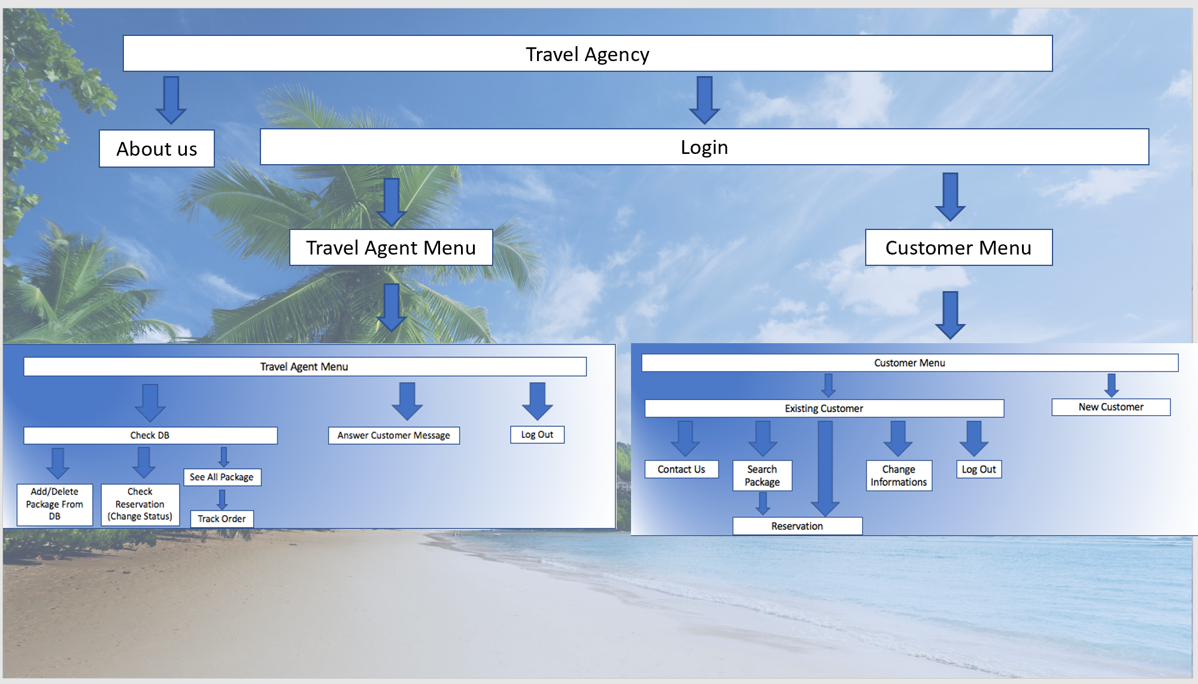
Appendix B: Analysis Models

Appendix C: To Be Determined List
- Interface design.
- Option to Accumulation of points on the purchase of packages .
The points will be redeemed by a benefit in subsequent purchases.
- Possibility to order transportation in sync with take-off and landing hours.
-Possibility to divide agents by areas and respond to customer inquiries according to specific destinations.

